COVID 19 – On Trial
Watch Video at: JoePlummer.com
Ladies and Gentlemen of the jury, we are witnessing madness. Worse, the perpetrators of this madness continue to stoke the flames!
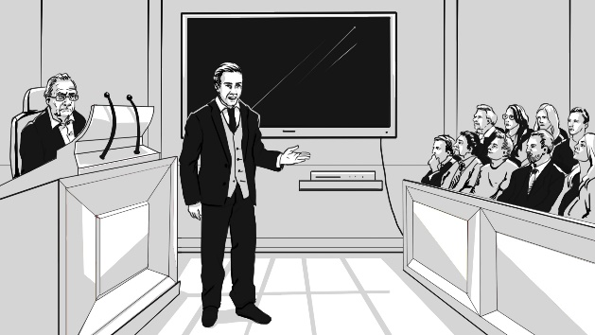
They would have us believe that we face a threat so deadly and dire, that our lives can never be the same. They would have us believe that every destructive policy they’ve enacted has not only been necessary, but that none of these policies have gone far enough! They would have us believe, to get back some of what they’ve taken, we must first give them more of what they want. But is any of it so? I will prove to you that it is not. Let’s take a closer look at the “threat” they have used to seize unprecedented power, destroy economies around the world, and secure trillions of dollars in bailouts.
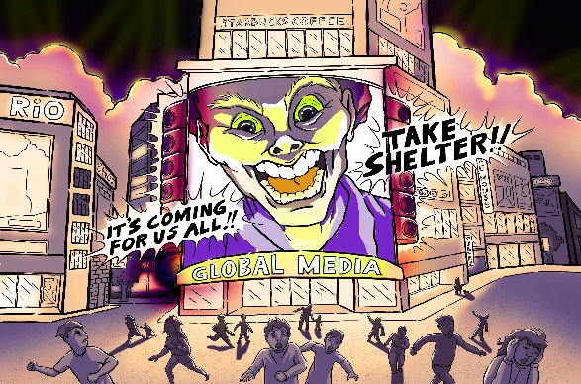
First, we need to address the number that health officials have been throwing around since the beginning of this so-called crisis: the potential Death Toll of COVID 19. If the current death toll hasn’t been exaggerated (we have reason to believe otherwise), and if the current death toll doubles, COVID 19 will kill approximately 1.5 million people around the world in 2020.

That number sounds very big, and the media has done everything within its power to convince you that it represents a significant threat to your life. The average person on the street can be forgiven for thinking that they, or somebody they love, will drop dead at any minute. Well, let’s examine this monster that they’ve created in the public’s mind.

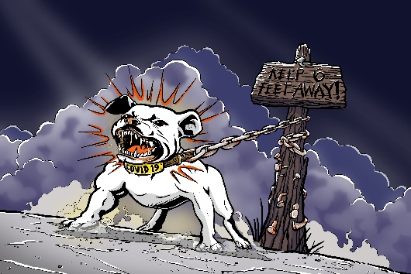
Here it is…And without any context, it looks like a vicious Pitbull on a 6-foot chain, waiting to maul anyone who gets within its reach. But is it? No, it’s not. In fact, cardiovascular disease (CVD) kills more than ten times as many people every single year; it truly dwarfs the threat of COVID 19. So, if we aim to keep this dog analogy accurate, we’re going to have to change this guy into something more appropriate, like a 5lb Chihuahua. We’ll let cardiovascular disease assume the role of a scary, 50lb Pitbull. Surely, if the COVID 19 Chihuahua is such a threat, then something that’s ten times more deadly should have killed us all by now…right?
Well, no. Cardiovascular disease is certainly deadly, but it’s nowhere near as deadly as all-cause mortality (ACM), which kills nearly 60 million people every year. Sooo…it looks like we’ve got to turn cardiovascular disease into something less scary; a Schnauzer, perhaps. And to represent the 60 million annual deaths, we’ll just have to pretend that there’s such a thing as a 200lb Pitbull.
Surely, if the COVID Chihuahua is deadly enough to shut down the world and create mass hysteria, then this guy, THIS GUY should have justified something unimaginably worse, right? …But it didn’t.
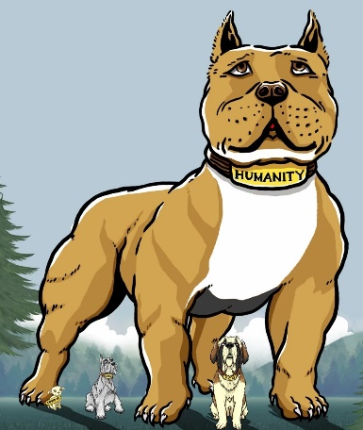
So how is it that we all managed to live our lives all these years despite this horrible threat? I’ll tell you how. Because this is nowhere near the biggest / baddest / toughest dog on the block. It’s more like a cuddly St Bernard compared to the real beast that we haven’t seen yet.

This monster isn’t twice as big, or 10 or 20 or 30 times as big…No, the biggest dog on the block is 125 times larger. Imagine if you can, a 25,000lb Pitbull. This Pitbull represents humanity. It represents the living / breathing strength of all the human beings that will not die, regardless of what the worst of these threats can throw at us.

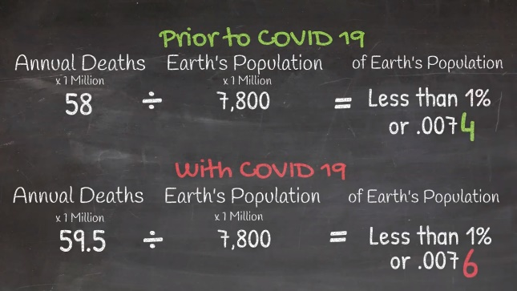
To really put this in perspective, let’s do some simple math on the blackboard: Prior to COVID 19, when we all lived normal lives, less than 1% of us died each year. (.007 of the earth’s population.) In 2020, with COVID 19, that number hasn’t changed. It’s still less than 1% of us, it’s still .007 of the earth’s population. The impact of this pandemic on total annual deaths is so small that you have to move into the 4th decimal place to measure it.

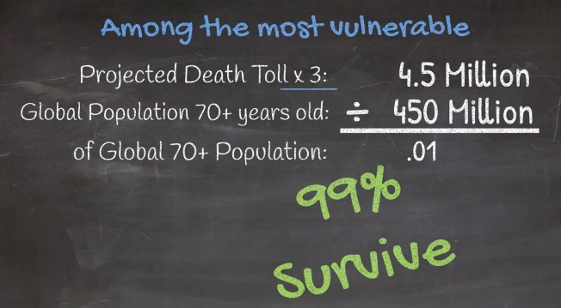
Even among the most vulnerable, those above the age of 70, COVID 19 would have to kill 4.5 million (3 times the projected death toll), to reduce their survival rate below 99%.
Does any of this sound like what you were led to believe? If not, then consider the harsh reality that you were intentionally misled. …You were intentionally misled.

